Waters and Communities Award
TidyTowns Competition 2023

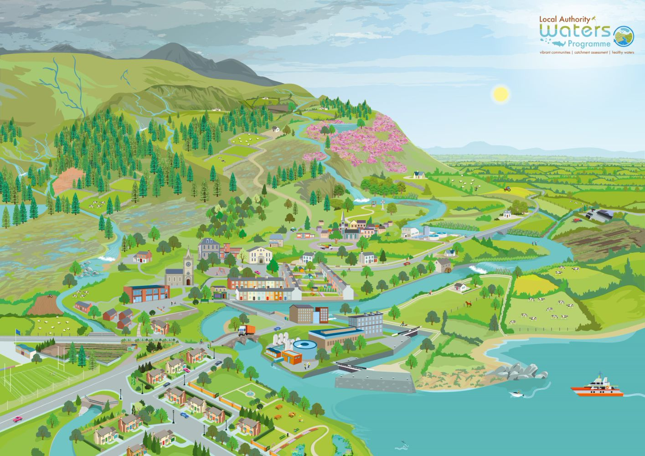

Community groups can play a vital role in the protection and improvement of our natural water environment. Together, we can protect our waters for future generations to enjoy.

This competition is open to community groups who have shown an appreciation for their water environment and water heritage during 2022
Waters and Communities Special Award Prize Fund 2023
Four Regional Award Winners Four Regional Runner Up Award Winners
€1,000 each €500 each
There will also be an additional prize of €1,000 for the overall winner of the four regions
The Waters and Communities Award is run in conjunction with the SuperValu TidyTowns competition
Closing Date:
See www.tidytowns.ie for more details about the main awards or other special awards
Note: if you are a winner, your group must provide details of a Bank/Credit Union account and a Tax ID number to the TidyTowns Unit. Payments are made by Electronic Funds Transfer only.

Background to the Waters and Communities Award

The Waters and Communities Special Award was first introduced in 2017 and has gone from strength to strength. We received 38 high quality applications in 2022. The award is to recognise communities who are taking positive steps towards raising awareness and showing appreciation of their local rivers, lakes, streams, canals and coast. The Award is sponsored by Inland Fisheries Ireland www.fisheriesireland.ie (responsible for the protection, conservation and promotion of Fisheries); Waterways Ireland www.waterwaysireland.org (responsible for the management of inland navigable waterways) and the Local Authority Waters Programme www.watersandcommunities.ie (working with communities to get involved in the management of natural waters).

Application Form for the TidyTowns Waters and Communities Award 2023
Name of TidyTown or other community group Main contact person’s name

Email: Phone:

Postal Address:

County of applicant group

Grid reference

Grid reference(s) of the exact location can be found on Google Maps https://www.google.ie/maps (For coordinates, right click on project area and click on ‘what’s here?)

Regions Counties
Midlands & East Dublin, Kildare, Laois, Longford, Louth, Meath, Offaly, Westmeath, Wicklow
North West & West Cavan, Donegal, Leitrim, Monaghan, Sligo, Galway, Mayo, Roscommon
South West & Mid-West Cork (North), Cork (South), Cork (West), Kerry, Clare, Limerick
South East Carlow, Kilkenny, Tipperary (North), Tipperary (South), Waterford, Wexford

- Awareness raising (15 Marks)
Please demonstrate how your community group has helped raised awareness of your local water body (eg. biodiversity and riparian planting, clean up, development of amenity area(s), water heritage projects, biodiversity signage, information leaflets, habitat surveys, bird boxes, outdoor classrooms, developing of safe access, control of invasive species, instream measures, promotion of angling, etc.) Max 200 words.

- Community involvement (20 Marks)
Please outline how your project involved the wider community? (e.g. did you work with schools, landowners or other groups?). Max 100 words.

- Stakeholder engagement (15 Marks)
Did you engage with your Local Authority or Local Development Company or any public agencies in developing your project? If so, please provide details. Max 100 words.

- Project benefits (40 Marks)
Please outline the long-term benefits of your project to the environment and local community (e.g. does it link in with the UN Sustainable Development Goals THE 17 GOALS | Sustainable Development (un.org)
Max 200 words.

- Highlights to share (10 Marks) Max 100 words.

Judging the Award

All entries will be assessed by a panel of judges appointed by Inland Fisheries Ireland, Waterways Ireland and the Local Authority Waters Programme. The panel of judges reserve the right to contact you to clarify any details submitted.

TidyTowns Competition Terms & Conditions apply as appropriate.
By entering this competition, you are giving permission to the sponsors to use information provided for any promotional purposes.
Closing date:
See www.tidytowns.ie for details of the main competition and other Special Awards

